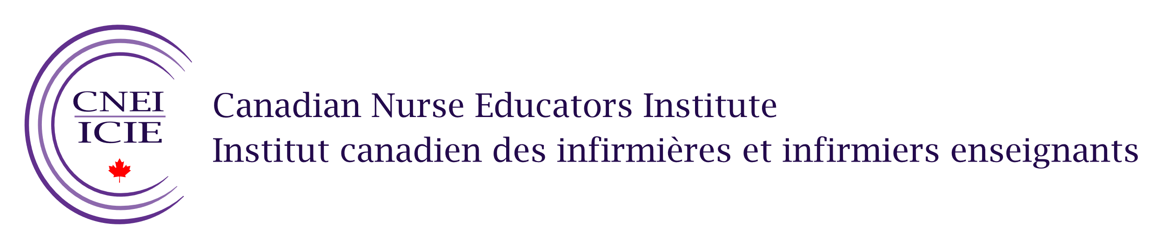

Publications Policy: CASN Nurse Educator Interest Groups

Purpose
This policy establishes guidelines for the review and dissemination of publications by CASN Nurse Educator Interest Groups.

Scope
This policy applies to all publications produced or endorsed by the interest groups that are intended for public consumption, including, but not limited to, manuscripts, articles, papers, and frameworks.

Publication Guidelines
- CASN mission: Publications must be directly relevant to the quality improvement of nursing education and scholarship and CASN’s mission of advancing nursing education, research, and scholarship in the interest of healthier Canadians.
- Evidence-informed: Publications must be informed by current evidence, best practices, and lived experiences. Publications must be free from plagiarism and sources must be cited appropriately.
- Inclusive language: Authors should be mindful of using language that is inclusive. Publications must not contain discriminatory language and/or hate speech.

Publication Venues
Interest group members are encouraged to collaborate on materials with the aim of external publication in order to contribute to the field of nursing education and nursing education research (e.g., peer-reviewed journals, academic conferences).
In cases in which these forms of publication are not appropriate, CASN offers two venues for publication:
- CASN newsletter: Interest groups may submit short articles that detail interest group activities, events, or developments in the field.
- CNEI Nurse Educator Interest Group webpage: Interest groups that have developed documents that are not appropriate for publication in an academic journal or through other venues may be allowed to post the document or publication on the Canadian Nurse Educators Institute (CNEI) webpage. Approved documents will be posted for 2 years and will then undergo a reapproval process.

Publications Process
Any use of the CASN name (including reference to the name of any CASN interest group) in a publication by an interest group must be submitted to CASN for review and approval.
- Interest group review: Members of the interest group must be provided the opportunity to review the document prior to submission to CASN.
- CASN review: Requests for review must be sent to education@casn.ca. Members of the CASN staff will review the publication to ensure the publication meets the publication guidelines. CASN reserves the right to refuse to publish or be named in publications that do not meet the publication guidelines.

Publication Disclaimer
Publications must include the following disclaimer:
***The views and opinions expressed by the members of the Nurse Educator Interest Groups (CASN) do not necessarily reflect the views of CASN.

